# Supporting Information

## *Polyphagy of the Oribius sp. Beetle*

## Fig. S1. Feeding preferences of *Oribius* sp. veevil. Values on the y axis represent the percentage of 20 no-choice feeding trials using an excised leaf and a single specimen of *Oribius* sp. beetle (placed in a container, after the beetle had been starved 24 hours) during which large feeding damage (defined as leaf holes bigger than body size projection of the beetle) occurred in 24 hours.

## *Within- and between- treatment beta-diversity*

We calculated multiple-site abundance-based Bray-Curtis dissimilarity (Baselga, 2017) and partitioned total beta-diversity into the component derived from species turnover (balance) and the component based on species gain and loss derived from nestedness (gradient). We used biomass as a measure of abundance.

All values of within-treatment dissimilarity are high, >0.75, and the component related to species turnover between sites dominates in all cases. The low nestedness component suggests that communities mainly change through species turnover rather than species loss from high- to low-diversity communities. This situation is different only in the insecticide treatment, where the communities are more similar and nested than in other treatments.

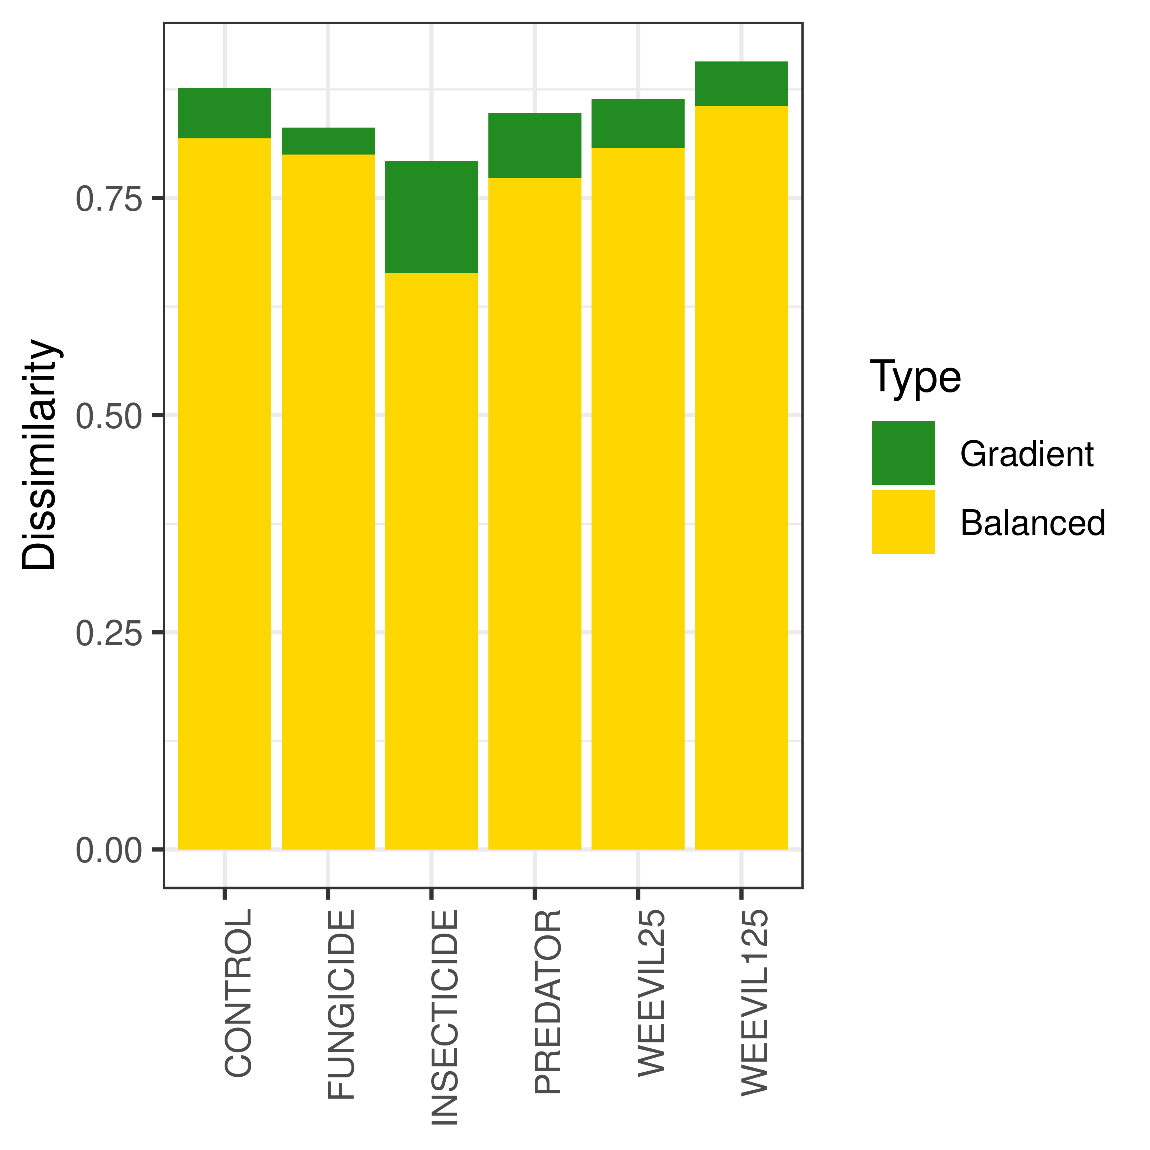Fig S2. Total within-treatment beta-diversity values partitioned into turnover (Balanced) and nestedness (Gradient) variation components.

## *Analysis of the most prevalent species*

## 

Fig S3. Relative abundance of the most prevalent species across experimental communities in pairwise comparisons between control and other treatments. Maximum likelihood estimates for the mean and 95% CI are plotted over individual data points. Significance of differences were determined using linear model with beta error distribution. Colors represent significance at alpha=0.05 (red) and alpha=0.1 (orange).

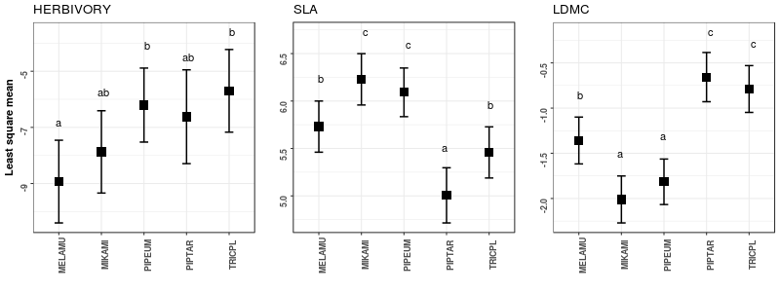Fig. S4. Average trait values in the control plots evaluated for the five most prevalent species. Significance was calculated with ANOVA and Tukey post-hoc test.

## References

Baselga, A. (2017). Partitioning abundance-based multiple-site dissimilarity into components: balanced variation in abundance and abundance gradients. *Methods in Ecology and Evolution*, *8*(7), 799–808. doi:10.1111/2041-210X.12693